CURRICULUM VITAE

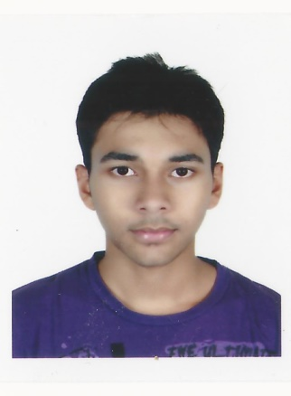

**SHAIKH REHAN HANEEF MOHAMMED**

|  |  |
| --- | --- |
| CONTACT INFO. |  |

Address : A-9-8 Fortune park block ‘A’, Serdang Perdana near south city   
 plaza, 43300 Kuala Lumpur, Malaysia.

Permanent Address : Arbaeen Street, Al-rehab district 2, P.O. Box: 65158  
 Jeddah, Saudi Arabia.  
   
Cell Phone No. : +60-1116310693 (Malaysia)  
 +966-555592350 (KSA)

Email ID : [rehan9394@hotmail.com](mailto:rehan9394@hotmail.com)

|  |
| --- |
| PERSONAL PARTICULARS |

Age : 22 years

Date Of Birth : 09th March 1994

Nationality : Indian

Gender : Male

Marital Status : Single

Passport No. : J4260772

Visa Type 1 : Residential visa (Jeddah)

Visa Type 2 : Malaysian Student Visa

|  |
| --- |
| EDUCATIONAL BACKGROUND |

**Bachelor’s Degree**

Field of study : Engineering

Major : B.Hons in Telecommunication

Institute : Asia Pacific University, Kuala Lumpur - Malaysia

Grade : 3.10 / 4.0 (last semester grade)

Graduation date : 2016

**Diploma**

Field of study : Engineering Diploma

Major : Electronics and Telecommunication

Institute : Mohammed Haji Saboo Siddik Polytechnic, Mumbai - India

Grade / Percentage: 73%

Graduation date : 2013

**High School**

Institute : International Indian School, Jeddah - K.S.A

Grade : 8.0 / 10.0

Graduation date : 2010

|  |
| --- |
| EMPLOYMENT HISTORY |

**Creative Tech. Trading Est**

Position Title : Assistant Sales Engineer

Position Level : Part timer

Industry : Reinforced Plastic and FRP products

Duration : 4 Months

**Superceed Sdn Bhd**

Position Title : Telecommunication Engineer

Position Level : Engineering Trainee

Industry : Telecom, IT sector

Duration : 3 months

**APIIT Corporate Training and Career Centre**

Position Title : Tele-Marketing

Position Level : Part timer

Industry : ICT Sector, Marketing

Duration : 6 months

|  |
| --- |
| TECHNICAL SKILLS |

* Ability to use MATLAB for simulation of digital signal and analog signal using codes and Simulink.
* Ability to use MATHCAD simulation for analysis of poles of the antenna.
* Analyzing network performance using Riverbed.
* Ability to use SIMULINK software to interact hardware components with the system.

|  |
| --- |
| NON - TECHNICAL SKILLS |

* Familiar with Word, Excel, Powerpoint.
* Website designer, Online marketing.
* Driving: Local and International License.

|  |
| --- |
| LANGUAGES |

English : Fluent

Hindi : Fluent

Arabic : Beginner

Urdu : Fluent

**Declaration:**

I hereby declare that the above-mentioned information is correct up to my knowledge and I bear the responsibility for the correctness of the above-mentioned particulars.